

Mini Project Report - 1

Master of Computer Application – General
Semester – I

Sub: Front End Frame Works

Topic:RESUME
By
Name: Arjun Reddy H S
Reg no.:
PROV/ASAC/MCA/7/26/071

Faculty Name: VEERA RAGHAV K

Faculty Signature: _______________

Department of Computer Application
Alliance University
Chandapura - Anekal Main Road, Anekal
Bengaluru - 562 106

August 2026
FIG NO: | NAME OF THE TABLE | PG NO:
1 | INTRODUCTION | 3
2 | INPUT CODE | 4-7
3 | OUTPUT CODE | 8
4 | CONCLUSION | 9
INDEX

INTRODUCTION
A Resume Builder Mini-Project is an interactive web application designed to simplify the creation of professional, standardized resumes. Built using modern front-end frameworks (such as React, Vue, or Angular), the application allows users to input personal details, work history, education, and technical skills into dynamic forms and instantly view a rendered, ATS-friendly document through real-time data binding.

INPUT CODE
<html>
<head>
<title>RESUME</title>
</head>
<body style="border:2px solid #292524; margin:20px; padding:30px; font-family:Arial, sans-serif; color:#292524;">

<h1 style="text-align:center; color:#292524; margin-bottom:10px;">

<u>Resume</u>

</h1>
<div style="text-align:center; margin-bottom:20px;">

<p> <b>Arjun Reddy H S</b></p>

<p><b>Email:</b><span style="color: blue;">hsarjun04@gmail.com</span>

<b>Phone:</b>91+ 6364696480
</p>

<p><b>Location:</b>Bengaluru,Karnataka</p>
</div>
<hr>

<!-- OBJECTIVE -->
<H2 style="color:#57534E;">
<u>Objective:</u>
</H2>

<p>Lorem ipsum dolor sit, amet consectetur adipisicing elit. Dolores, eum ex totam tempora in praesentium porro, odit fugit iusto autem quae repellat velit natus non recusandae enim ducimus, suscipit mollitia blanditiis ullam? Natus architecto, dicta magnam cum culpa perferendis, exercitationem dolor accusantium reprehenderit cupiditate eos doloremque est fugiat quas libero nulla rem maiores recusandae adipisci a. Veniam debitis necessitatibus soluta.</p>
<hr>

<H2> <u>Qualifications:</u></H2>
<table border="2px" style="border-collapse:collapse; width:100%; text-align:center;">

<thead >
<tr >
<th>SL No</th>
<th>College name</th>
<th>Course</th>
<th>Marks</th>
<th>Percentage</th>
<th>YOP</th>
</tr>
</thead>
<tbody>
<tr >
<td>1</td>
<td>SSMRV PU College</td>
<td>PCMC</td>
<td>8.5</td>
<td>85%</td>
<td>2023</td>
</tr>
<tr >
<td>2</td>
<td>THE OXFORD COLLEGE OF SCIENMCE </td>
<td>UG</td>
<td>9.0</td>
<td>90%</td>
<td>2026</td>
</tr>
<tr >
<td>3</td>
<td>ALLIANCE UNIVERSITY</td>
<td>MCA</td>
<td>9.5</td>
<td>95%</td>
<td>2028</td>
</tr>
</table>
<hr>
<h2><u>Skills:</u></h2>
<ul>
<li>Programming Languages: Python, Java, C++</li>
<li>Web Development: HTML, CSS, JavaScript</li>
<li>Database Management: SQL, MongoDB</li>
</ul>
<hr>
<h2><u>Projects:</u></h2>
<p>Lorem ipsum dolor sit, amet consectetur adipisicing elit. Quibusdam unde vel, ducimus ea tenetur beatae ab! Eum tempora similique veniam pariatur. Sapiente nulla neque aliquid obcaecati, illo ex aspernatur, non distinctio asperiores veniam tenetur? Iste, impedit ut. Eligendi pariatur veniam voluptates ipsum, non tempore nemo dicta sint laboriosam quos consectetur.</p>
<hr>
<h2><u>Certificates:</u></h2>
<p>Lorem ipsum dolor sit amet consectetur adipisicing elit.</p>
<hr>
<h2><u>Achievements:</u></h2>
<p>Lorem ipsum dolor sit amet consectetur adipisicing elit. Quisquam asperiores maiores ut laborum autem beatae voluptatibus porro quis corrupti eaque facilis sapiente sit accusamus minima necessitatibus nemo, veniam amet, atque voluptas perferendis! Reiciendis quo perspiciatis eum maxime esse exercitationem ducimus ipsum earum culpa, eveniet dolorem excepturi tenetur vero possimus quis.</p>
<hr>
<h2><u>Hobbies:</u></h2>
<p>Lorem ipsum dolor sit amet consectetur adipisicing elit. Quisquam asperiores maiores ut laborum autem beatae voluptatibus porro quis corrupti eaque facilis sapiente sit accusamus minima necessitatibus nemo, veniam amet, atque voluptas perferendis! Reiciendis quo perspiciatis eum maxime esse exercitationem ducimus ipsum earum culpa, eveniet dolorem excepturi tenetur vero possimus quis.</p>
<hr>
<h2><u>Work Experience:</u></h2>
<p>Lorem ipsum dolor sit amet consectetur adipisicing elit. Quisquam asperiores maiores ut laborum autem beatae voluptatibus porro quis corrupti eaque facilis sapiente sit accusamus minima necessitatibus nemo, veniam amet, atque voluptas perferendis! Reiciendis quo perspiciatis eum maxime esse exercitationem ducimus ipsum earum culpa, eveniet dolorem excepturi tenetur vero possimus quis.</p>
<hr>
<h2><u>Strength and Weaknesses:</u></h2>
<ul>
<li>Strengths: Strong problem-solving skills, good communication abilities</li>
<li>Weaknesses: Sometimes overthink situations, can be a perfectionist</li>
</ul>
<hr>
<p>Date: _____________</p>
<p>Place:________________</p>
<p>Signature: _________________</p>
</body>
</html>

OUTPUT CODE
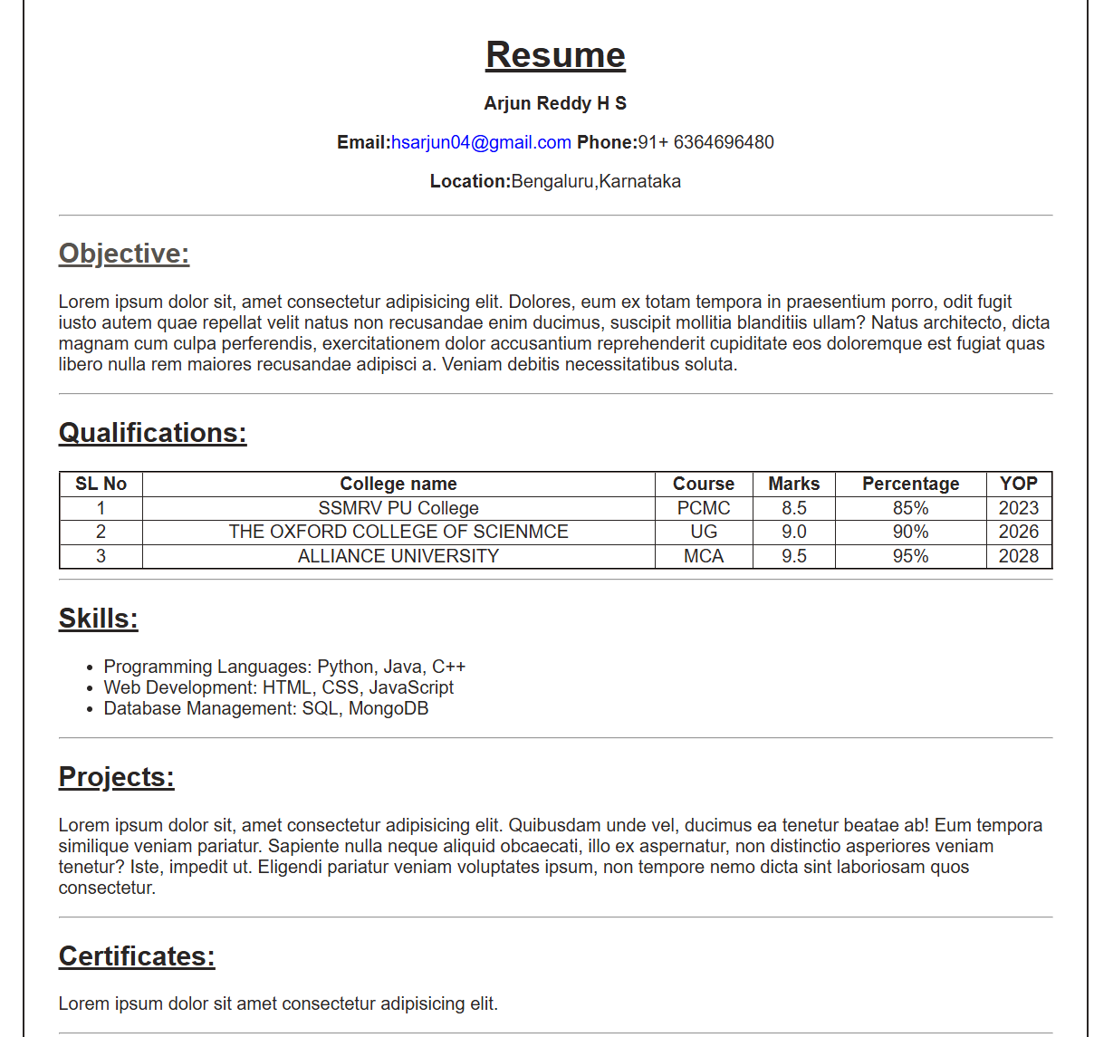

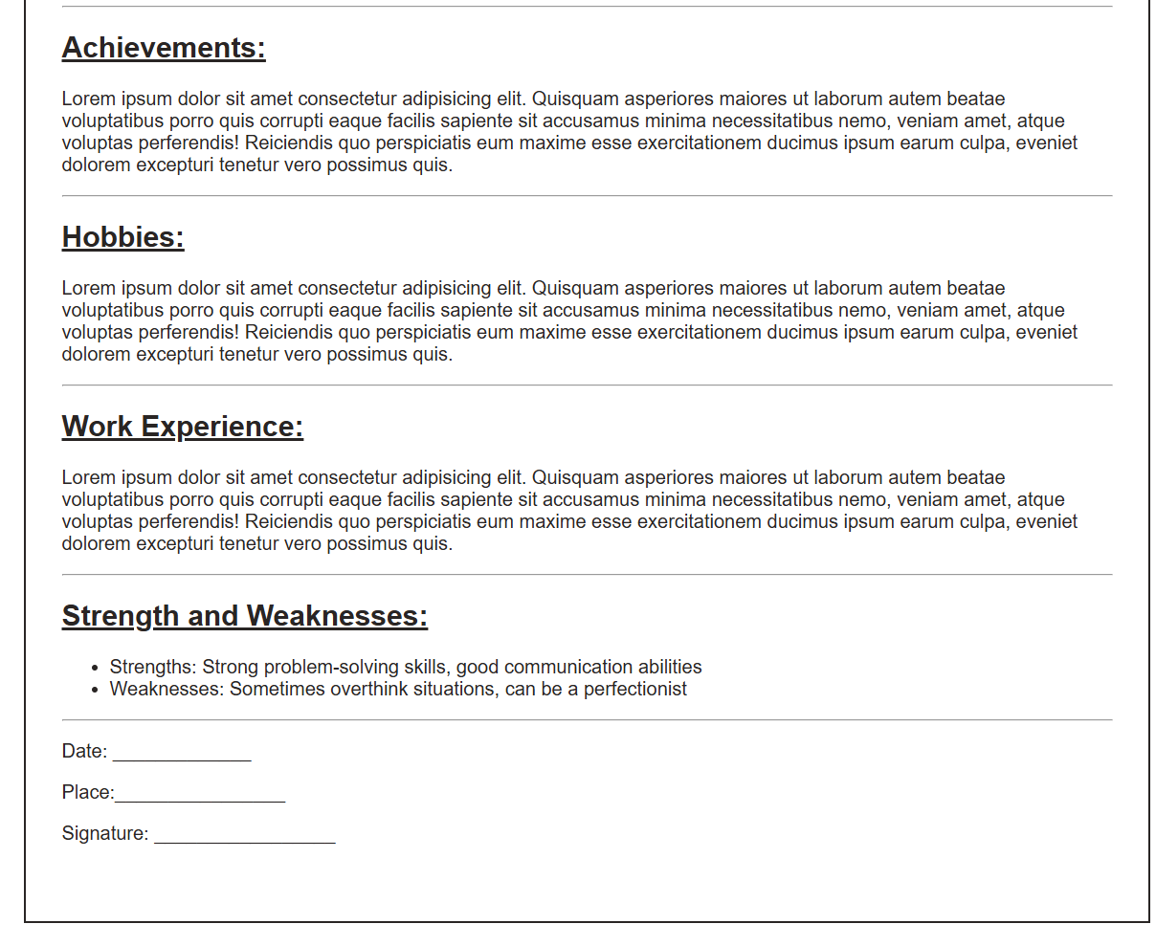

CONCLUSION
The Resume Builder Mini-Project effectively demonstrates the power of modern front-end frameworks in creating responsive, data-driven web applications. By translating user input into a structured, live-updating visual document, the project reinforces core software development concepts such as component modularity, reactive state handling, dynamic DOM updates, and print-optimized CSS layout design.
Beyond its utility as a functional tool for generating clean, ATS-compliant resumes, this project provides a solid foundation for more advanced features, such as multi-template rendering, client-side PDF export, persistent browser storage, and backend API integration for user account management.

